DATE: 2016.12.30

ASR 6477: Outbound creation to allow import Detail line from excel file:

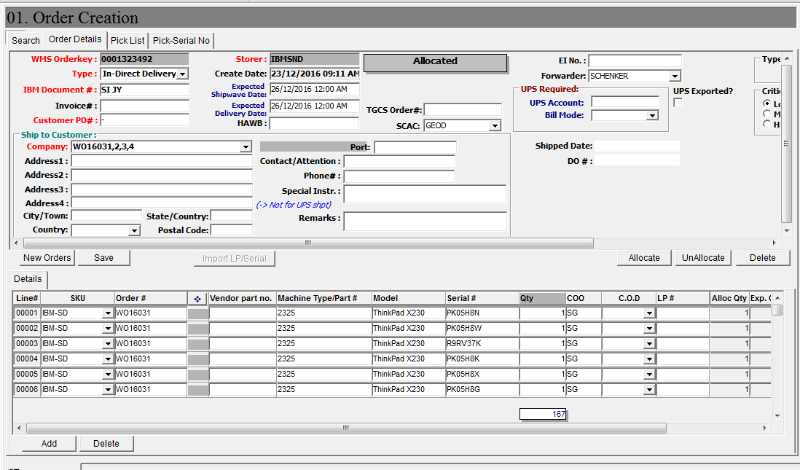

Import detail

1. **User to create [New Orders]**
2. Add button **[Import Detail] , to import order detail from excel file.**
3. Import template file format:

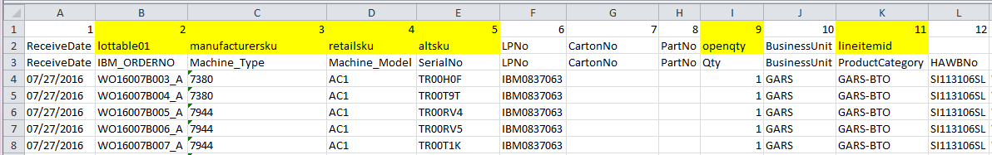

1. System auto insert row to Order detail.

WMS Changes:

[Outbound] -> Order Creation

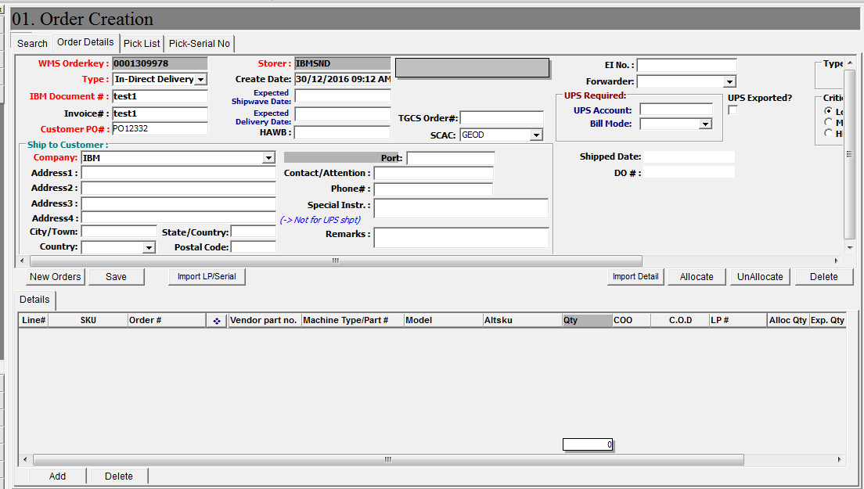

Import Order Detail function

** NOTE: **for CISCO order, require to remove the duplicate Carton/Part detail line.**

**Steps:**

1. Create new order, click button[New Orders]
2. Input IBM document #, Customer PO# and Company
3. Click [Import Detail].

A window screen pop put to select import file,

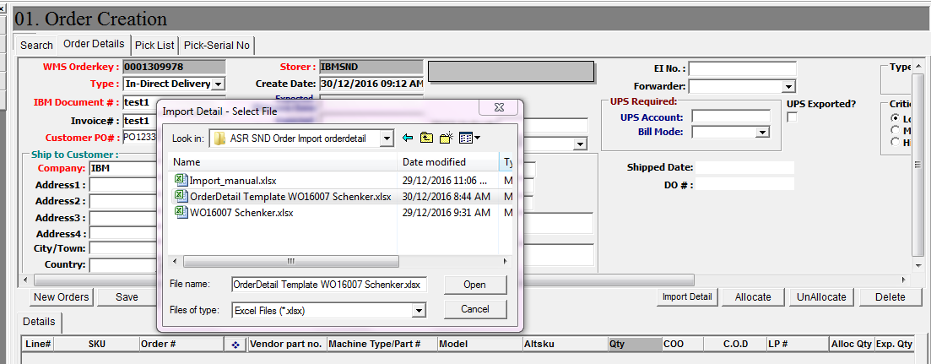

Click [Open] to continue import file

System will auto –insert detail lines.

After imported success, system will prompt number of rows processed.

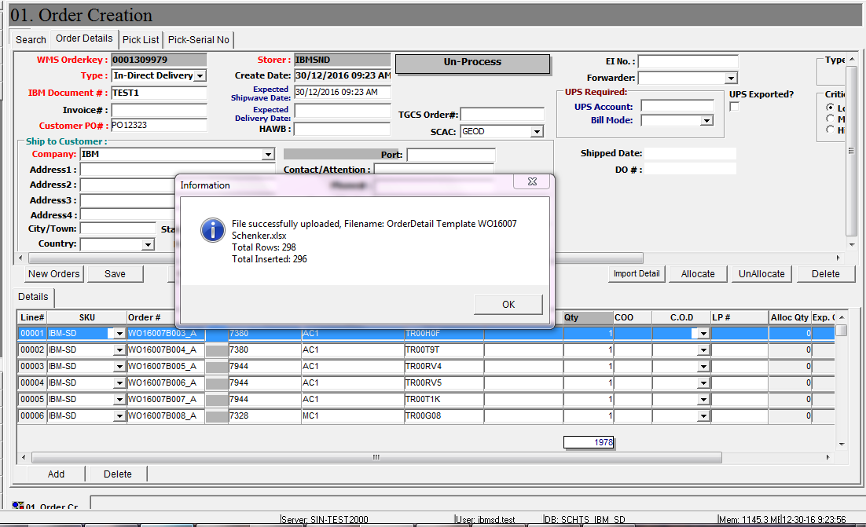

Sample Template – import detail:

